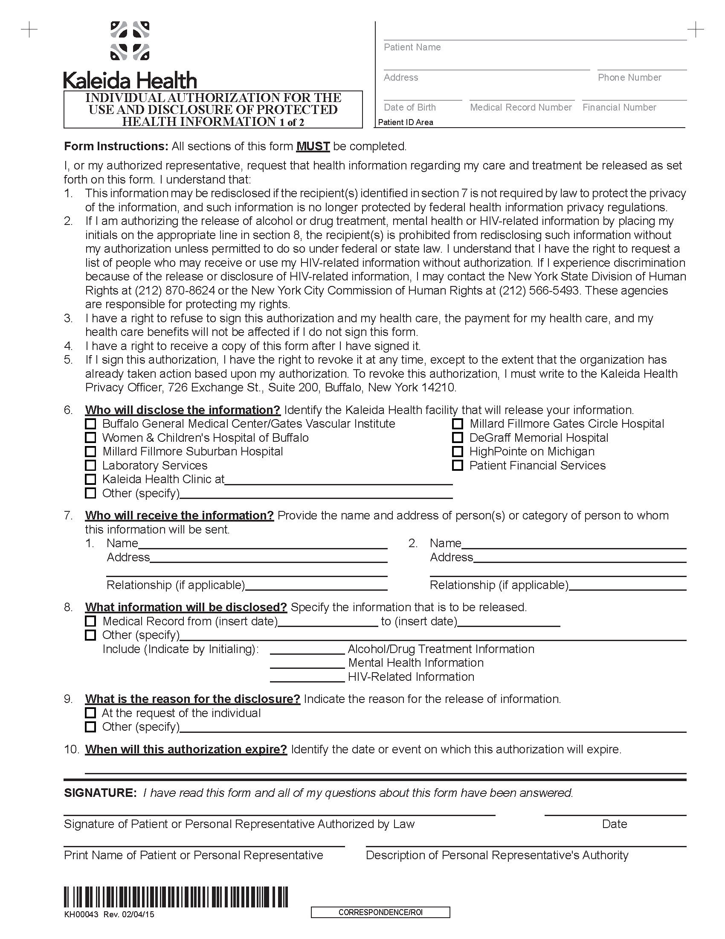
Batman
Secret Location Gotham, NJ
01/01/1979
University of Michigan Hospital and Health Center
x
Axiom Requisition Copy Service
2869 Jolly Road
Okemos, MI 48864 PH: (877) 886-5090
FROM 01/01/1979 TO PRESENT: Any and all MEDICAL RECORDS, including but not limited to patient history form(s), reports, etc. pertaining to Batman SSN: xxx-xx-5555, DOB: 01/01/1979.
x
Litigation
End of Litigation
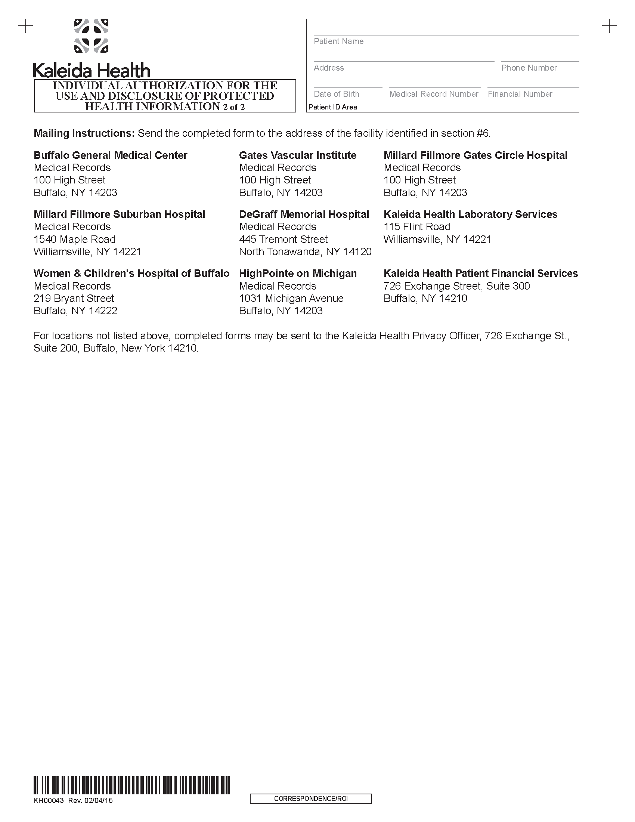
Batman
Secret Location Gotham, NJ
01/01/1979

